

**UNIVERSITI TUNKU ABDUL RAHMAN**

**Lee Kong Chian Faculty of Engineering and Science**

**UEMH 4523 Micro-ElectroMechanical System (MEMS)**

**Group Assignment Report**

**Student’s Particulars:**

|  |  |  |  |
| --- | --- | --- | --- |
| **No.** | **Name** | **Student ID.** | **Course** |
| 1. | Kung Jie Sheng | 1601630 | MH |
| 2. | Moi Soon Seng | 1607003 | ME |
| 3. | Nur Hapinder Binti Abdullah | 1607515 | ME |

**Lecturer’s Name :** Dr. Chee Pei Song

**Submission Deadline :** 28th August 2020

**Group Assignment Mark :**

Electroactive Polymer (EAP) Development For Aerospace Engineering

Kung Jie Sheng, Lee Jian Jet, Moi Soon Seng, Nur Hapinder

Email for: jasonkung98@gmail.com, moisoonseng@gmail.com, happy.tulip1@gmail.com

*Abstract*—This report is about the application of EAP on aerospace engineering. The drag force can play an important role in aerospace engineering by reducing the surface friction.

# **Introduction**

The EAP has many usages in the aerospace engineering and one of the usages is the turbulent friction drag reduction. The turbulence has to be reduced because it generate friction, which in turn would generate heat, thus it would create power loss for the aircraft. Besides that, it can also save the cost of fuel as well.

So, in order to reduce the problem faced, electroactive active polymer can be used to detect the amount stress applied by the air stress or wind stress on the actuator. With the change of voltage detect by the actuator, which can limit the unwanted motion in the direction of the spanwise. One of the most important would be DEAP (Dielectric Electro Active Polymers).

The DEAP (Dielectric Electro Active Polymers) can provide large strains when the electrodes are been subjected to very large voltage that has placed between two electrodes. DEAPs have many advantages like good efficiencies, fast response, high energy densities and large active deformations.

# **DESIGN AND WORKING PRINCIPLE**

The general principle of electroactive polymer is the directional migration effect of charged particles [1]. There are two main types of working principle in electroactive polymer (EAP) which are ionic and electronic EAPs.

## **Ionic EAP**

During electrical stimulation, there is a displacement of ions in the ionic EAP that causes the ions to change its shape or volume. The ions are required to maintain its ‘wetness’ during all times when the ions are diffused inside the electrolyte and the main advantage of it is the voltage actuated are low like 1 to 2 V. Although the ionic EAP has a slow response speed but it has strong bending capabilities and is commonly used for bending actuators. The ionic EAP are usually expensive due to the configuration of stable material production is difficult and are not always commercially available.

## **Electronic EAP**

The strong electric field is the major drive for electronic EAPs. The electromechanical change in shape of the material is caused by the occurring electrostatic forces. Due to the large in-plane deformation of electronic EAP, so it is commonly used as planar actuators. The activation voltage of electronic EAP is very high which can range up to several kilovolts so they need to work in dry conditions. The electronic EAP under DC activation is able to hold the induced displacement, provide large activation stresses and are very fast in response.

## **Electromagnetic EAP**

Besides ionic and electronic EAP, electromagnetic EAP is another emerging EAP that utilizes the magnetic force from either permanent magnets or from electromagnet. Electromagnet provides more flexibility to control compare to magnet EAP as the magnetic field generate can be alter by changing the current supply to the EAP. The EAP can be developed , for example having a known mass suspended between the four spring of equal stiffness that is lying flat on a plate which can be driven at resonant frequency.

## **Device Structure and Operation**

The electroactive polymer produced by National Aeronautics and Space Administration (NASA) is made of ceramic inclusions between the layers that has multilayered polyimide structures. Some of the examples of the multilayered structures are ceramic inclusion within a polymer matrix that has carbon nanotubes (CNTs) in the two-phase polymer composite that is dispersed in the polymer matrix. Another example is an intrinsic unimorph that has three-phase composite formed during single-walled CNT (SW CNT) of the polyimide matrix.

The research of this paper would utilize the two tile actuators. The device is a resonant device that would execute with amplitude that is close to the in-plane spanewise oscillations or the streak spacing that are larger than the turbulent flow.

## **Mathematically Modelling/ Equations**

The force displacement that is generated due to the voltage applied between the electrodes that depend on the permittivity and the Young Modulus of elastomer. The elastomer Young Modulus (Y) is inversely proportional to the actuation deformation ($γ$), but $γ$ is proportional to the elastomer permittivity ($ε$) in virtual electrode model.

$$γ= εε_{0}E²/Y$$

Where,

$ε_{0}$ = air permittivity

E = the applied electric field

To calculate the air force drag:

The wall shear stress $τ_{w}$ = ${Re}_{θ}$ = $\frac{U_{∞}θ}{v}$ $≈$ 2500;

Where $θ$ is the momentum thickness.

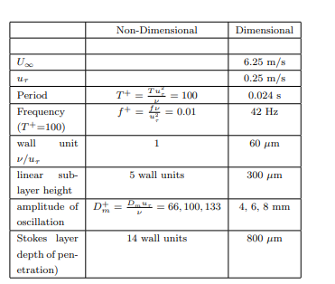

**Figure 1: The theoretical parameter used in the current experiment.**

## **Device Geometrical Drawing**

# **FABRICATION**

DEAP (Dielectric Electro Active Polymers) is fabricated using surface micromachining. The substrate used in the surface micromachining involves of processing the substrate in the foundation layer on which to be build. The layer of thin films formed when the material is added to the substrate which is typically it is made from silicon wafer.

The sacrificial layers can either be structural layers or it can acts as spacers that will be removed later. Because of the sacrificial layer, the process would require two different materials that would require a structural material to act as a free standing structure that is usually made of polysilicon, polycrystalline silicon or silicon nitride where the sacrificial material will be deposited. The sacrificial material will be deposited on a free standing mechanical structure with the aid of oxide or an open area at an open area. The sacrificial material will wet etched away to reveal the final structure after the layers of deposited thin films that has been dry etched subsequently in sequence.

The cross-sectional area of the test-section model 1 is with the following dimension of 320 $μ$ m $×$ 40 $μ$ m $×$ 5 $μ$ m (Length $×$ Width $×$ Height) sandwiching a piece of silicon material with a dimension of 300 $μ$ m $×$ 60 $μ$ m $×$ 5 $μ$ m ((Length $×$ Width $×$ Height). The second model is a rectangular model with a dimension of 120 $μm$ (L) $×$ 40 $μm$ (W) $×$ 5 $μm$ (H).

PDMS (polydimethylsiloxane) is used in the actuator that is constituted by a polymer film that is sandwiched between two compliant electrodes. The PDMS is embedded within two gold electrodes, where the top part of the electrode is free to move which is attracted under actuation whereas the bottom part is fixed. The gold electrode is evaporated by a PVD process by using conventional method lift-off method, whereas the elastomer is patterned on the wafer and is made photosensitive.

**RESULTS**

A. Finite element modeling (FEM)

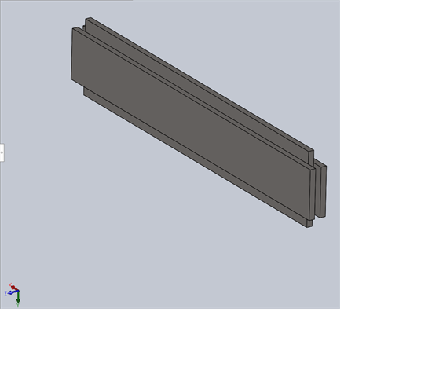

Figure 1 First model made of silicon.

Figure 1 above shows the first model produced that is made of silicon. The fixture of the material is set to have fixed geometry on one side of the structure and rollers (or sliders) are applied on the other end of the structure. On the end where rollers are applied, there is also a force of 5N acting perpendicularly on the structure.

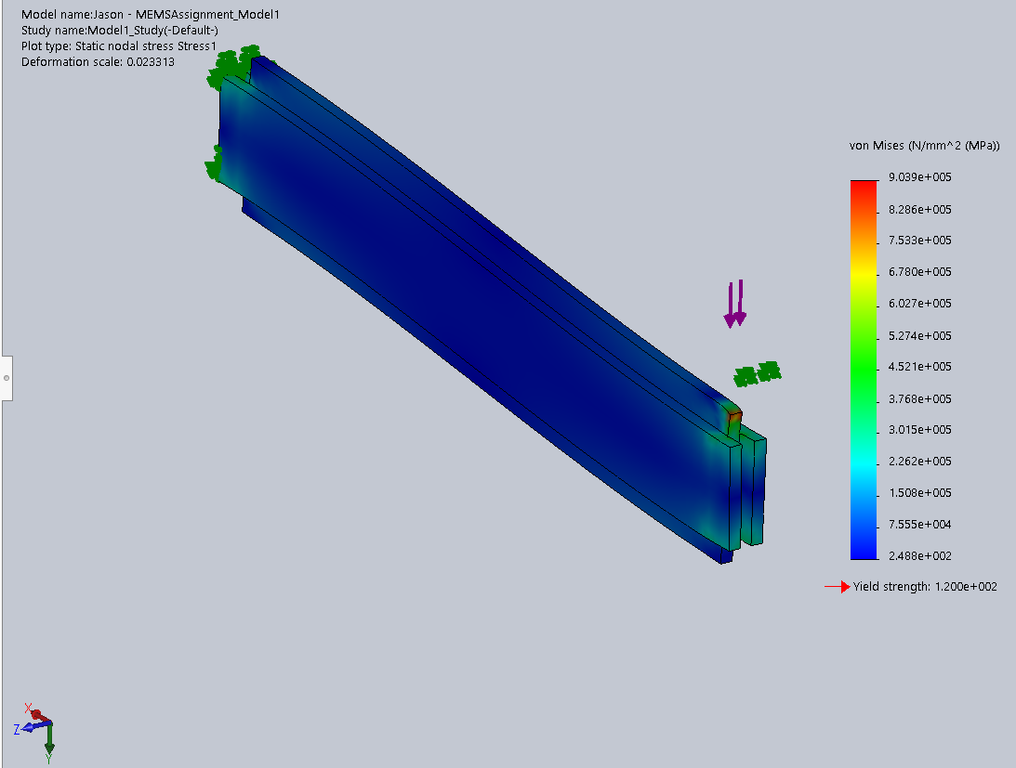

Figure 2 Model 1 that undergoes simulation of static study.

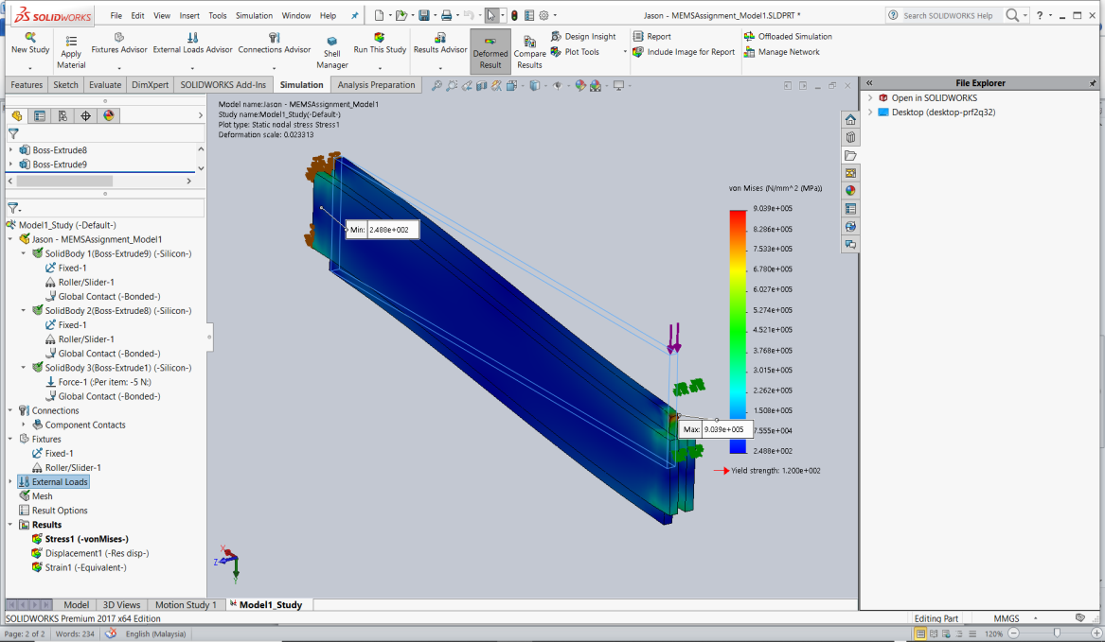After running the simulation study, the results are shown in Figure 2 above. It can be observed that the whole structure has a von Mises stress of 248.8 MPa, which is also the minimum stress existed on the structure. The maximum stress is located at the tip of the structure near the roller end of the structure, which the stress reached 9.039 105 MPa, whereas the minimum stress existed is 248.8 MPa. It is also due to the reason that the existence of external load introduced to the system that causes the stress to be much higher on the loaded side. The yield strength calculated from the simulation for the structure is shown as 120 MPa. The simulation also shows that the model has a deformation scale of 0.023313. The simulation data is shown in Figure 3 below,

Figure 4 below shows the second model produced that is made of the same material, which is silicon. The structure is made up of two pieces of silicon material with a dimension of 120 $μ$ m $×$ 5 $μ$ m $×$ 40 $μ$ m (Length $×$ Width $×$ Height). The fixture of the material is set to have fixed geometry on one side of the structure and rollers (or sliders) are applied on the other end of the structure. On the end where rollers are applied, there is also a force of 5N acting perpendicularly on the structure. Similarly, simulation is conducted again for the second model.

**V CONCLUSION**

State what you have achieved, mathematically modelling? Equation?

<https://www.lboro.ac.uk/microsites/mechman/research/ipm-ktn/pdf/Technology_review/an-introduction-to-mems.pdf>

##### **References**

1. Wang, Y. and Sugino, T. (2018). Ionic Polymer Actuators: Principle, Fabrication and Applications. Actuators. [online] Available at: https://cdn.intechopen.com/pdfs/59893.pdf [Accessed 16 Sep. 2019].
2. <http://www.pitt.edu/~qiw4/Academic/MEMS1082/Group%202%20EAPs%20review%20-%20Final%20Paper.pdf>
3. <https://backend.orbit.dtu.dk/ws/files/105170153/978_87_93054_45_5_Sindhu_Vudayagiri.pdf>